ACCURACY CHARACTERISTICS ASSESSMENT OF AN EARTH REMOTE SENSING SATELLITE ATTITUDE CONTROL SYSTEM OVER OBSERVATION INTERVALS

A. S. Galkina, I. V. Platoshin

Progress Space-Rocket Centre JSC, Samara, Russian Federation

The authors consider problems of assessing accuracy characteristics of an attitude control system taking into account specific interaction of an optronic complex with charge-coupled devices with time-delay integration (CCD TDI) over intervals of Earth observation and stellar sky imaging. As a solution, an algorithm is proposed to determine acceptable accuracy characteristics, which is developed subject to angular motion conditions over observation intervals. The article gives an example of calculating accuracy parameters of a control system by the proposed algorithm.

Keywords: image motion speed, image shift, orientation error, angular velocity error, angular motion, optical system, exposure time.

Further you can find a shortened version of the text, which is given for illustrative purposes only.
At present, most Earth remote sensing (ERS) satellites feature high spatial resolution of data acquired by them as well as high accuracy of cartographic video data binding. One of technological perfection characteristics for ERS satellites is their optronics complex (OC) resolution capability, which depends first of all on the technical characteristics of a satellite control system. To realize OC resolution capability, it is necessary to provide several accuracy characteristics of the satellite control system over Earth observation intervals [1].
The up-to-date ERS satellites use optical systems with charge-coupled devices with time-delay integration (CCD TDIs). For such systems, the exposure time of one pixel tП is less than that of the whole resolution cell (t_{Н}) and is determined by the following relation [1-3]:

(1)
where δ_{П} is the pixel size of an image receiver, n_{Ш} is the number of storage rows in the matrix, V_{СК} is the speed of image motion in the focal plane. By resolution cell we mean projection of an Earth’s surface area onto the sensing element of the optical-to-electrical converter (pixel).

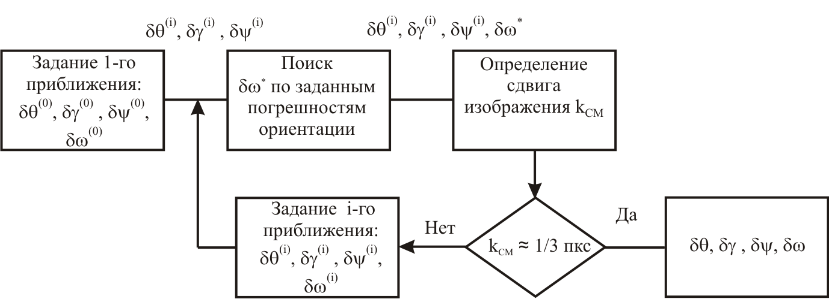

Fig.1 – Flow chart of algorithm determining control accuracy over an observation interval

Thus the proposed algorithm allows determining necessary accuracy characteristics of an Earth remote sensing satellite control system subject to the condition of non-exceeding the allowable image shift across the sensing equipment swath over the intervals of the stellar sky and Earth’s surface observation in the specified range of deviation of the central line of sight from the nadir and yaw angle (relative azimuth).
Choice of control system accuracy characteristics depends on the image motion speed range realized by an OC, storage row number, orbital parameters, and specified angular motion. The requirements to the angular motion accuracy become stricter at increasing the storage row number and choosing the image motion speed range, where imaging is performed with pitch deceleration.

References
- Anshakov, G.P., Manturov, A.I., Ustalov, Ju.M., Gorelov, Yu.N. Earth remote sensing satellite angular motion control. // Polyot. 2006. № 6. Pages 12-18.
- Borodin, M.S. Technology of tree-axis scanning by optronic space imaging systems. Cosmonautics and Rocket Engineering // Cosmonautics and Rocket Engineering. 2008. № 2(51). Pages 75-82.
- Zanin, K.A., Khailov M.N. Setting of earth remote sensing spacecraft dynamics requirements // Polyot. 2009. № 5. Pages 32-37.
- Kuznetsov, P.K., Martemyanov B.V. Mathematical model of video data acquisition with the application of scanning CCD mode // Izvestia Samarskogo Nauchnogo Tsentra RAN. 2014. Т.16, № 6. Pages 292-299.

Authors Information
Galkina, Anastasia Sergeevna, Candidate of Engineering, leading design engineer, Progress Space-Rocket Centre JSC, 18, ul. Zemetsa, Samara, 443009, Russia, tel. (846) 228-91-71. Scientific area: spacecraft angular motion control.
Platoshin, Igor Vyacheslavovich, Bachelor of Mechanics, design engineer, Progress Space-Rocket Centre JSC, 18, ul. Zemetsa, Samara, 443009, Russia, tel. (846) 228-91-71. Scientific area: spacecraft angular motion control.

